## Reverse Vending Machine with Advanced Plastic Bottle Detection using Deep Learning and SVM

**A Thesis Presented to the Faculty of the**

**College of Computing Studies, Information and**

**Communication Technology**

**Isabela State University**

**Cauayan Campus**

**In Partial Fulfillment of the Requirements for the Degree**

**Bachelor of Science in Computer Science**

**Comia, Dhon Amado L.**

**Morete, Christian Arthur B.**

**June 2024**

APPROVAL SHEET

The Thesis entitled *Reverse Vending Machine with Advanced Plastic Bottle Detection using Deep Learning and SVM*, has been prepared and submitted by Comia, Dhon Amado L. and Morete, Christian Arthur B., in partial fulfillment of the requirements for the degree Bachelor of Science in Computer Science Major in Data Mining is hereby endorsed.

|  |  |
| --- | --- |
| **Dr. Joel M. Guimiran** | |
| Research Paper Adviser | |
| Approved by the panel of the final oral and system defense with a grade of _________.  **Reynaldo R. Corpuz, DIT** | |
| Chair, Defense Panel | |
| **Rosemary R. Velasco, DIT** | **Jayson Liquigan** |
| Panel Member | Panel Member |



Accepted as partial fulfillment of the requirements for the degree Bachelor of Science in Computer Science Major in Data Mining.

**ROSEMARY R. VELASCO, DIT** ______________

Program Chair, BSCS Date

**REYNALDO R. CORPUZ, DIT** ______________

Dean, CCSICT Date

**LORELEI C. TABAGO, Ph. D.** ______________

Director, ISU Cauayan Research and Development Date

Recorded:

**CLARIZA P. ORATA, MBA** ______________

Registrar II, ISU Cauayan Date

ACKNOWLEDGMENT

We would like to send our Gratitude to all of the Professors, Classmates, Friends and Families for the support of our Thesis Making without your supports we would not be able to finish this paper.

**God.** Thank you for the guidance and grace that you have given to us Researchers without your grace and your provisions we would not be able to have the strength to carry on and push through in our paper

**Families.** We give our hearts to our Families who always stood by us in our hardest times without them we would not have the courage and

DEDICATION

This portion is optional but perhaps you have someone or some people who have inspired you to push on with your studies? A dedication would be a fitting way to acknowledge their impact on your success.

# ABSTRACT

This study introduces a Reverse Vending Machine (RVM) that leverages deep learning and Support Vector Machine (SVM) technologies for efficient plastic bottle detection and recycling. By combining a Convolutional Neural Network (CNN) for image analysis with SVM for classification, the system achieves high accuracy and real-time performance. Innovations like virtual detection lines and Kalman filters optimize computational efficiency and prediction stability. The RVM enhances recycling by accurately identifying recyclable materials, reducing contamination, and promoting sustainability. Future work aims to expand material recognition and improve adaptability in real-world conditions.

# Table of Contents

ABSTRACT v

Table of Contents vi

LIST OF TABLES viii

LIST OF FIGURES ix

1 1

1.1 1

1.2 **Error! Bookmark not defined.**

1.3 5

1.4 **Error! Bookmark not defined.**

2 7

2.1 7

2.2 11

2.3 12

3 13

3.1 13

3.1.1 13

3.1.2 14

3.1.3 14

3.2 15

3.2.1 15

3.2.2 17

3.2.3 18

4 **Error! Bookmark not defined.**

4.1 **Error! Bookmark not defined.**

4.2 **Error! Bookmark not defined.**

5 **Error! Bookmark not defined.**

5.1 **Error! Bookmark not defined.**

5.2 **Error! Bookmark not defined.**

5.3 **Error! Bookmark not defined.**

# LIST OF TABLES

Insert the List of Tables using the “References” tab > “Insert Table of Figures” > Table

# LIST OF FIGURES

Insert the List of Tables using the “References” tab > “Insert Table of Figures” > Figures

# INTRODUCTION

## Background of the Study

One of the global environmental concerns is plastic pollution, where single-use PET (Polyethylene Terephthalate) and HDPE (High-Density Polyethylene) bottles account for most solid waste flows. Precise identification is very important in automatic recycling machines such as reverse vending machines (RVMs). Despite an RVM being made up of mechanical, electrical, and software elements, this thesis focuses on creating and evaluating models for bottle recognition that form the intelligent kernel part of such machines. Effective waste management would thus form the first approach towards resolving the menace of disposal of solid waste that degrades public health as well as ecological completeness. However, many cities experience overflowing trash containers through regular or ineffective modes of waste handling. Therefore, there is an urge for an online real-time monitoring system capable of giving feedback on waste container fill status for appropriate prompt removal of wastes.

Reverse vending machines (RVMs) are self-service collection units that incentivize customers to bring in used beverage containers by rewarding them with a refund, coupon, or other value after deposit. First appearing in Europe in the 1970s, modern RVMs now employ mechanical sorting, reading from bar codes or RFID, and increasingly sophisticated arrays of sensors to process high numbers at low rates of error (Duraković & Andrić, 2018). Subsequent developments have improved performance under varying circumstances (Froehlich, Müller, & Schmid, 2007) and added sophisticated control systems for dynamic algorithms for sorting (Steger & Rentschler, 2019).

Wong et al. (2022) discussed the challenges faced in modern waste management systems. They stressed that effective waste management can enhance a nation’s standing in global sustainability efforts. Proper disposal systems and innovative solutions like RVMs can significantly impact the environment and foster sustainable practices. Communities and industries are recognizing the profound effects of proper waste management on reducing environmental footprints and promoting recycling.

Machine learning algorithms have been used to improve material discrimination in RVMs. Support Vector Machines (SVMs) are typical supervised classifiers that seek an optimal hyperplane in feature space, commonly making use of kernel functions to address non-linear separability (Vapnik, 1995). SVMs have been used in recycling to discriminate between plastics in terms of spectral or textural features with robust performance at relatively moderate computational costs (Rajić, Čupić, & Dadic, 2016). Reference books provide in-depth treatments in SVM theory and application (Cristianini & Shawe-Taylor, 2000).

Conversely, Convolutional Neural Networks (CNNs) had been designed to learn in an automatic fashion hierarchical features directly from raw images. CNNs have achieved state-of-the-art performance for object recognition and have an advantage in finding and localizing bottles in complicated backgrounds (LeCun, Bengio, & Hinton, 2015). Landmark publications highlight their capability in large-scale image classification (Krizhevsky, Sutskever, & Hinton, 2012) as well as very deep architecture advantages (Simonyan & Zisserman, 2015).

In addition to the above studies, Naga City recently partnered with Ocean Bound Plastic Recycling Philippines, Inc. to address plastic waste and promote ecological balance Plastic Bank Ecosystem, (2022). Through this initiative, plastic waste is recycled into valuable resources, tackling the pressing issue of ocean pollution while addressing poverty. In contrast, Cauayan City LGU incentivizes plastic recycling by offering rice in exchange for collected plastic waste. However, using rice as currency is not a sustainable long-term solution. Installing RVMs where plastic bottles can be recycled for cash incentives would encourage waste segregation and support Sustainable Development Goals.

Recent studies stress the importance of Reverse Vending Machines (RVM) in addressing the mounting problems associated with plastic waste and harm to the environment. By way of technologies like Convolutional Neural Networks (CNN) and Support Vector Machines (SVM), RVMs will break ground in waste management: they allow for more precise plastic detection, which lessens the chances of contamination and subsequently increases recycling rates.

This method will also reduce the environmental risks and thereby help meet the Sustainable Development Goals by advancing a circular economy and enabling communities to get involved in waste management. The roll-out of these systems would change the tenor of urban and municipal waste programmers, increasing efficiency in tackling the problems we are faced with today.

## Objectives of the Study

This thesis is committed to developing two independent models for plastic-bottle-only RVM detection:

* Support Vector Machine (SVM): We use optical (color histogram, edge descriptors) and weight sensor hand-crafted features to achieve high accuracy at minimum inference delay by optimizing regularization and kernel selection.
* Convolutional Neural Network (CNN): We develop an efficient CNN architecture using transfer learning, and we train on an annotated data set for images with varied lighting and background settings.

1. Data set creation: Create and annotate a sample data set for PET bottles and HDPE bottles.
2. Model Development: Specify features for the SVM pipeline and design an efficient CNN for deployment on an edge.
3. Training & Evaluation: Models compared on accuracy, precision, recall, inference time, and resource usage.
4. Deployment Analysis: Assess memory consumption and energy usage to inform realistic RVM integration.

By employing these metrics, showcasing trade-offs between standard techniques and deep-learning techniques for embedded recycling operations.

## Significance of the Study

The value in this research is in making contributions to sustainable waste management and intelligent automation by means of targeted development in object recognition for plastic bottles. In tackling RVMs' detection aspect through conventional machine learning (SVM) and deep learning (CNN) methods, this study seeks to:

1. Enhance the precision and performance of RVM systems by minimizing false positive results and false negatives in bottle recognition.
2. Facilitate more efficient use of RVM technology in computationally limited or network-constrained settings.
3. Provide insights on comparative advantages and limitations between SVM and CNN for implemented smart recycling solutions.

This study contributes to international environmental efforts by promoting recycling practices and guiding future AI-based sustainability development. The resulting detection models may support increased public uptake and performance of smart RVMs in urban and remote settings.

## Scope and Delimitations

The system is limited to classifying plastic bottles and excludes other materials such as metals and glass. The algorithms are trained on a curated dataset, and extreme conditions or objects outside this dataset may affect performance. Hardware optimization and large-scale deployment scenarios are beyond the scope of this study. This research emphasizes the potential of CNN and SVM for automated recycling, acknowledging the need for future improvements.

# THEORETICAL FRAMEWORK

## Review of Related Literature

**Theme 1: Reverse Vending Machines (RVMs) and Their Applications**

Reverse vending machines have gained popularity as a supposed solution for efficient recycling of plastic bottles. Automating collection and sorting, these machines improve recycling rates and suppress plastic waste. Gaur et al. (2018) state that reverse vending machines have gained popularity in countries with rigorous recycling laws in view of overloaded landfills and the harmful gases generated by waste landfilling. Gaur et al. stated that RVMs are helping establish smart waste management systems and promote recycling behaviors.

Some research into the functionality of reverse vending machines has taken note of their flexibility and efficiency across contexts. An example is a system suggested by Kim et al. (2021), which classifies recyclable waste such as plastic, glass, and cans through the use of barcode, vision, and near-infrared sensors. Such a design achieved from 85% to 95% sorting efficiency while effectively showcasing a new approach for small convenience store applications.

Tomari developed RVM prototypes that integrate with municipal recycling bins and show a 97% user-interaction success rate aimed at allowing improved waste sorting in Malaysia. Wong reiterated the idea that reverse vending machines form an integral part of countries making efforts to attain sustainable waste management and recycling. They suggested such integration in both public and private sectors.

**Theme 2: Deep Learning for Plastic Detection**

Deep learning techniques, particularly Convolutional Neural Networks (CNNs), are integral to enhancing the detection capabilities of RVMs. CNNs excel in extracting visual features from images, enabling accurate classification of plastic bottles even under varying environmental conditions. Patel et al. (2019) noted that CNN-based object detection systems have revolutionized traditional methods by improving accuracy and speed.

The adoption of advanced CNN architectures has further refined object detection processes. For instance, Faisal et al. (2022) proposed a Faster R-CNN model capable of candidate region extraction, feature classification, and bounding box regression. Despite its high accuracy, the approach highlighted challenges in convergence speed, which were mitigated through Mask R-CNN’s object masking capabilities.

Single-stage detectors like YOLO and SSD are preferred for real-time applications due to their speed. Chen and Zhang (2020) introduced a multi-scale CNN with a pyramid pooling module, enhancing detection accuracy for small and large objects. This innovation significantly reduced identification errors, particularly for objects that are typically overlooked by conventional models.

**Theme 3: Support Vector Machines (SVMs) for Classification and Tracking**

Support Vector Machines (SVMs) complement deep learning models in classification tasks, offering robust performance in high-dimensional spaces. In the context of RVMs, SVMs are employed to classify detected objects as plastic or non-plastic. Yan et al. (Author, Year) demonstrated the integration of image processing and SVMs to accurately identify beverage containers, leveraging ResNet-50 for feature extraction.

SVMs are also effective in tracking applications, associating detected objects across frames for consistent identification. Gochoo et al. (2023) applied SVMs to fisheye camera images, improving object recognition in distorted environments. Similarly, Liu et al. (2020) utilized SVMs for detecting small traffic signs in adverse weather, showcasing the algorithm's resilience under challenging conditions.

**Theme 4: Technological Innovations in Waste Management**

Beyond detection and classification, innovations in waste management technologies focus on optimizing system performance. Virtual detection lines, as proposed by Kadikis et al. (2021), enhance computational efficiency by processing only the pixels within predefined areas. This method significantly reduces the computational load while maintaining accuracy.

Edge detection techniques further support efficient processing. Sharma et al. (2019) reviewed traditional methods like Sobel and Canny operators alongside advanced approaches, emphasizing their importance in structural property preservation. These methods, combined with virtual detection lines, streamline the processing pipeline in RVM systems.

**Theme 5: Enhancing Recycling Through Feature Extraction**

Feature extraction plays a crucial role in plastic bottle recycling. Ramli (2020) demonstrated the use of morphological operations and bounding rectangles to calculate bottle angles and heights, ensuring precise sorting. The application of Kalman filters further smoothed velocity estimates, enhancing real-time monitoring.

Tan et al. (2018) introduced a novel segmentation method for PET bottle identification, utilizing polarization and refractive index data for robust material classification. Özkan et al. (Author, Year) proposed combining Principal Component Analysis (PCA), Kernel PCA, and other techniques for feature extraction, employing SVMs for final classification. This approach improved accuracy while reducing computational overhead.

**Synthesis**

The integration of deep learning and SVM technologies within RVM systems demonstrates significant potential in addressing global plastic waste challenges. CNNs provide accurate detection and classification, while SVMs enhance tracking and robustness. Technological innovations, such as virtual detection lines and advanced feature extraction methods, further optimize system performance. Collectively, these advancements pave the way for more efficient and scalable recycling solutions, contributing to sustainable waste management practices.

## Conceptual Framework

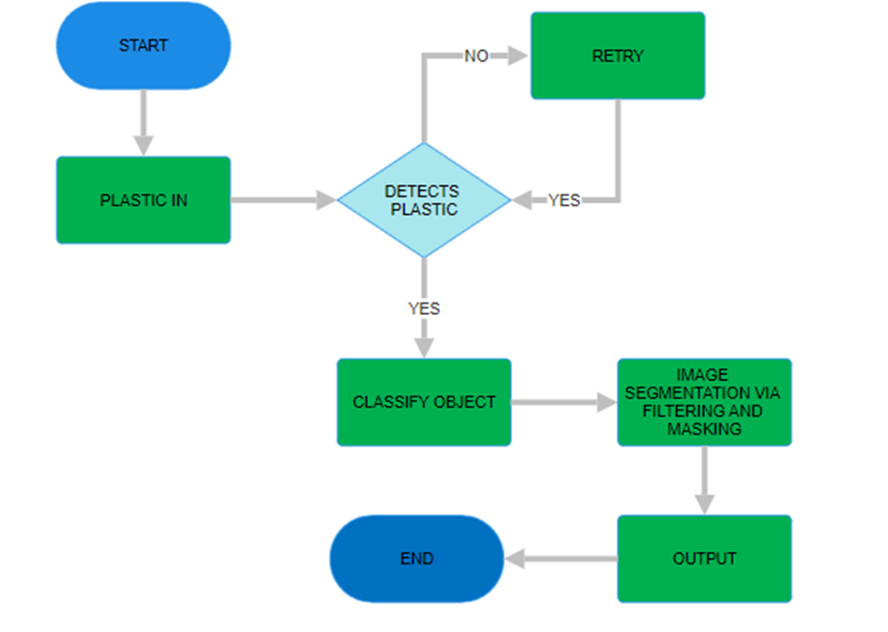

**Figure 1.** A Process for classification of plastic bottle

The technique used in the classification is the CNN and the SVM where it holds a high percentage pair up with image segmentation and image masking for the filtering and recognition of the captured image through its edges. The smart bins functionality mainly focuses on the detection and the classification of plastic waste.

## Definition of Terms

A **Convolutional Neural Network (CNN)** is a deep learning algorithm refined for image and video analysis. It is a sort of machine learning model that applies concepts from linear algebra, more specifically convolution operations, to feature-extract and pattern-recognize in images.

**Heuristic approaches** can be defined as those which do solve a problem applying more practical methods, mental shortcuts, or broad rules of thumb, instead of specific theoretical methods.

**Image segmentation** partitions a digital image into multiple segments-image regions or image objects, i.e. sets of pixels.

**Internet of things devices** are connected to the Internet or other communications networks and contain enough intrinsic processing, sensors, and software to enable them to exchange data with other devices and systems.

**Support Vector Machines** A supervised max-margin models with associated learning algorithms, for classification and regression analysis.

# OPERATIONAL FRAMEWORK

## Materials

This section provides a detailed description of the materials, components, and methods used to develop the reverse vending machine (RVM) system with advanced plastic bottle detection using deep learning and Support Vector Machine (SVM) algorithms.

### Software

**Programming Languages**: Python was used for image processing, machine learning, and integration with the RVM's control system.

**Machine Learning Frameworks**:

* **TensorFlow/Keras**: Used for developing the deep learning-based plastic bottle detection model.
* **scikit-learn**: Utilized for implementing the Support Vector Machine (SVM) classification model.
* **OpenCV**: Used for real-time image processing, including feature extraction, image pre-processing, and handling camera input.

### Hardware

**Arduino R3 Board**: Used for Communication from board to the other parts of the prototype

**Load Cell (5kgs):** Tells the weight of the bottles inside

**0.96 OLED Screen**: For the display output of the bottles

**OVO7670**: Detects the Plastic as it goes in

### Data

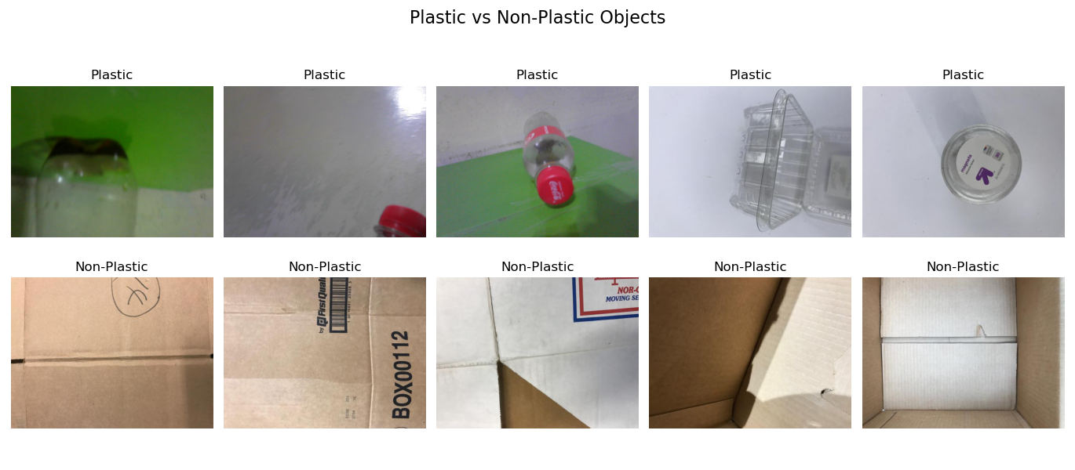The data for this project was gathered from a combination of publicly available datasets on Kaggle and custom real-time data obtained through our own image captures. The Kaggle datasets offered a foundational collection of labeled images pertinent to recycling and waste classification, which we enhanced with real-time data collected through direct image capture. This dual approach enabled the creation of a diverse dataset that not only includes curated, high-quality labeled images but also reflects the real-world variability encountered in actual conditions. This makes the dataset more representative of the scenarios typically faced in a practical reverse vending machine setup.

***Figure 2.*** *Dataset from real-world applications*

## Methods

### Experimental design

This study adopts a quantitative experimental design, utilizing image processing techniques for the purpose of image classification and performance evaluation. The methodology is organized into three key phases: data preparation, model training and optimization, and evaluation. Each phase is carefully structured to ensure thorough assessment and improvement of classification performance, contributing to the overall effectiveness and reliability of the proposed image processing system.

**Data Collection and Preparation**

* Data augmentation: Carried out image transformations including rotation, flipping, scaling, and brightness adjustments to increase diversity of the training data.
* Image Labeling: Bottles were labeled either as "Plastic" or "Non-Plastic" for classifying the CNN.
* Preprocessing: Images were resized and normalized to have consistent sizes across the dataset.

**Plastic Bottle Detection**

* Convolutional Neural Network (CNN): It is an algorithm designed to classify images into two classes: Plastic and Non-Plastic.
* Architecture: The CNN consists of convolutional layers for feature extraction, pooling layers to reduce dimensionality, and fully connected layers for classification.
* Training: The model was trained on the labeled dataset with cross-entropy loss and the Adam optimizer.
* Evaluation Metrics: Accuracy, F1 score, and mean average precision (mAP) were used to quantify how well a model performed.

**SVM for Tracking**

* The SVM algorithm was installed for tracking of the detected objects across multiple frames.
* Features: Outputs from the CNN were used as input features for the SVM.
* Training: SVM was trained on a portion of the dataset to classify the objects and maintain its identity.

**System Integration**

* The trained CNN model was deployed on the onboard computer of the RVM for real-time detection.
* A user interface is developed to show the detection results and the states of the vending machine.

**Evaluation**

* **Confusion Matrix**: Used to measure the model performance in correctly classifying plastic and non-plastic items.
* **Inference Time**: Evaluated for confirming that the real-time processing capability was still available.
* **Tracking Accuracy**: Assessed in SVM performance in identifying objects with consistency across frames.

### Procedures for the different phases

**Phase 1: Data Preparation**

* Gather images from the Kaggle dataset and the real-time camera.
* Perform data cleaning to ensure optimal input for the models.
* Label the data into the required classes.

#### **Phase 2: Model Training**

* Train the CNN model using the prepared dataset.
* Optimize hyperparameters (e.g., learning rate, number of layers) to improve performance.
* Validate the model using unseen test data.

**Phase 3: System Implementation**

* Integrate the trained CNN into the RVM system.
* Implement the SVM-based tracking mechanism.
* Test the system under real-world conditions to ensure reliability.

**Phase 4: Evaluation**

* Collect data on the model’s classification accuracy, F1 score, and inference time.
* Use confusion matrices to analyze misclassifications.
* Assess the overall system’s efficiency and user-friendliness.

# RESULTS AND DISCUSSION

## Results by phase of study

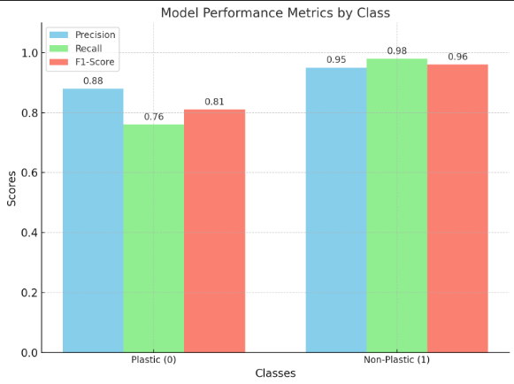

***Figure 3.*** *Model Performance of the SVM algorithm*

The bar chart illustrates the performance metrics of the Support Vector Machine Model across two classes: Plastic (0) and Non-Plastic (1), showcasing an overall accuracy of 93%. For the Plastic class (0), the SVM achieved a precision of 88%, meaning that 88% of the items predicted as plastic were indeed accurate. Its recall was measured at 76%, indicating that the model successfully identified 76% of all actual plastic items. The F1-score for this class stood at 81%, reflecting a balance between precision and recall.

In contrast, the model performed better for the Non-Plastic class (1), attaining a precision of 95%, which indicates that 95% of the items predicted as non-plastic were correct. The recall was notably high at 98%, demonstrating that the model recognized 98% of all actual non-plastic items. The F1-score for this class was an impressive 96%, underscoring its strong efficacy in detecting non-plastic items. Overall, the chart reveals that while the model excels in identifying non-plastic items, its performance in plastic detection remains commendable.

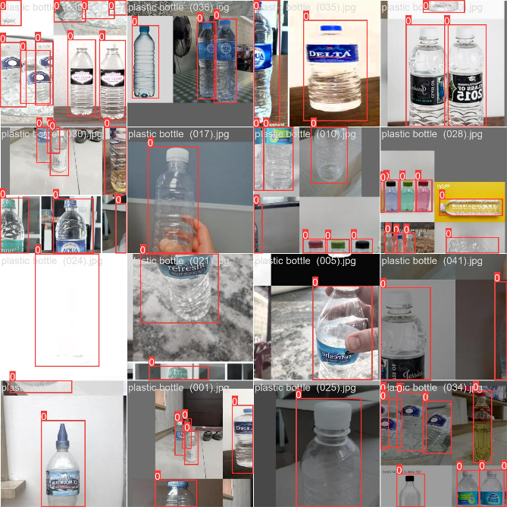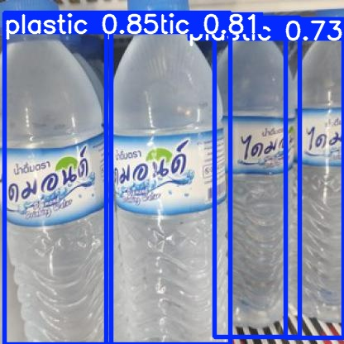

***Figure 4.*** *Detection of SVM Algorithm Using Bounding Boxes*

The Model can determine whether the object is plastic or not by showing the bounding boxes. It also shows how the model behaves when it comes to its detection rate as shown using bounding boxes

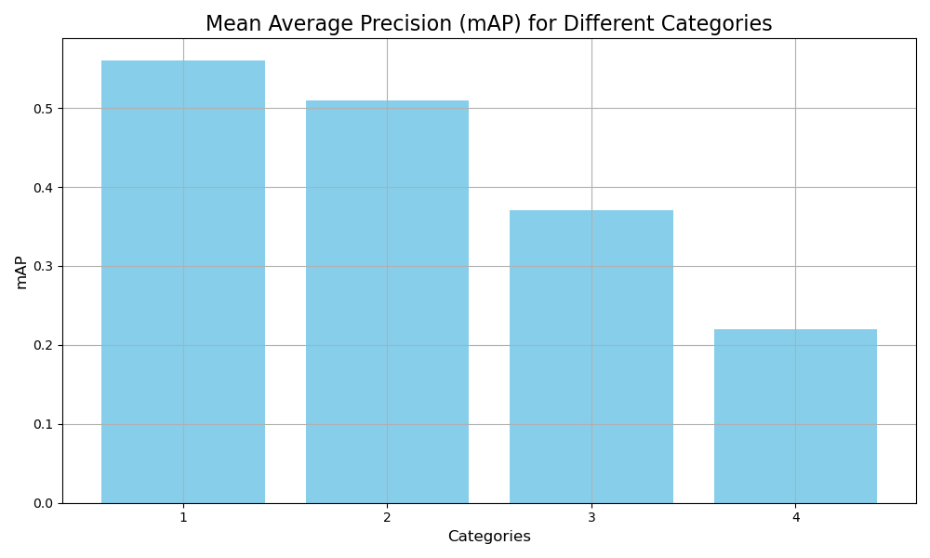

***Figure 5.*** *Mean Average Precision results in CNN*

The bar graph shows the mAp of the system using CNN algorithm where the first epoch performs reasonably well with the value of 0.56 while the 2nd epoch returns a value of 0.51 a slightly lower performance it still able to detect, in the 3rd epoch the system struggles to detect while at the 4th epoch it drops significant where it can barely detect the object

|  |  |  |
| --- | --- | --- |
|  |  |  |
|  |  |  |

***Figure 6****. Accuracy, Precision and Results of the model using CNN (Top) and SVM (bottom)*

The model exhibits an impressive overall accuracy of 93%. This figure signifies that 93% of the predictions made by the model for both classes are correct. Analyzing precision, the Plastic (0) class reports a precision rate of 88%, which implies that when an item is predicted as plastic, there is an 88% likelihood it genuinely belongs to this category. In contrast, the Non-Plastic (1) class achieves a higher precision at 95%, showcasing the model's remarkable dependability in identifying non-plastic items.

Regarding recall, the model effectively recognizes 76% of actual plastic items, indicating that it successfully detects a significant portion of true plastic classifications. For the Non-Plastic (1) class, recall stands out impressively at 98%, reflecting the model's strong capability to identify non-plastic items accurately.

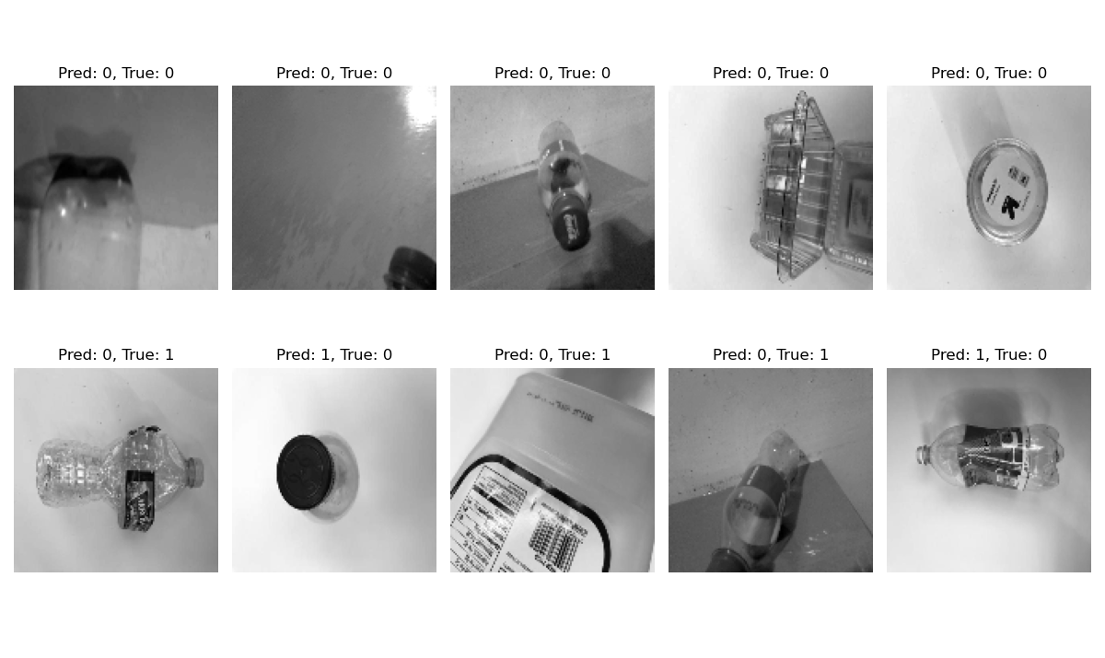Overall observations from the charts reveal that performance metrics favor the Non-Plastic (1) class across all measures. Conversely, while assessing performance in detecting plastic items within the Plastic (0) class, lower-than-anticipated precision and recall rates suggest an opportunity for enhancement in recognizing these materials more effectively.

***Figure 7.*** *Object Classification using SVM if it is plastic or not*

As demonstrated in the table above, the model is designed to distinguish between plastic and non-plastic objects with high accuracy. Leveraging its classification capabilities, the model evaluates each item and determines its category based on learned features. This classification process is reflected in the high precision rates, particularly for the Non-Plastic (1) class, which highlights the model's strong reliability in correctly identifying non-plastic items. Similarly, the Plastic (0) class shows a commendable precision rate, ensuring that predictions for plastic items are largely accurate.

|  |  |
| --- | --- |
| SPEED (PRE-PROCESSED) | INFERENCE TIME (ms) |
| 0.1ms pre-process | 2.6ms |

***Figure 8.*** *Speed and Inference time using CNN algorithm*

This table provides performance metrics for a machine learning or AI system, showing how quickly it handles input preparation and inference. A total time of 2.7 ms (pre-processing + inference) suggests that this is a high-performance system suitable for real-time or near-real-time applications.

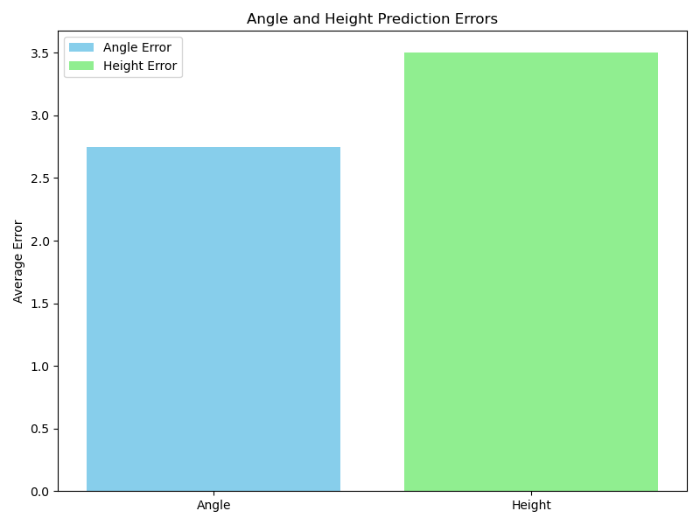

***Figure 9.*** *Results of the Angle and Height Accuracy*

The graph shows a comparison between angle error and height error in prediction tasks. The blue bar represents the angle error, with an average error of approximately 2.5. This suggests that the model performs relatively well in predicting angles, with lower error values. On the other hand, the green bar represents the height error, which has a significantly higher average error of about 3.5. This indicates that predicting height is more challenging for the model, as the error in height predictions is higher compared to angle predictions. The larger height error suggests that the model may need improvements or more data to enhance its accuracy in predicting height values

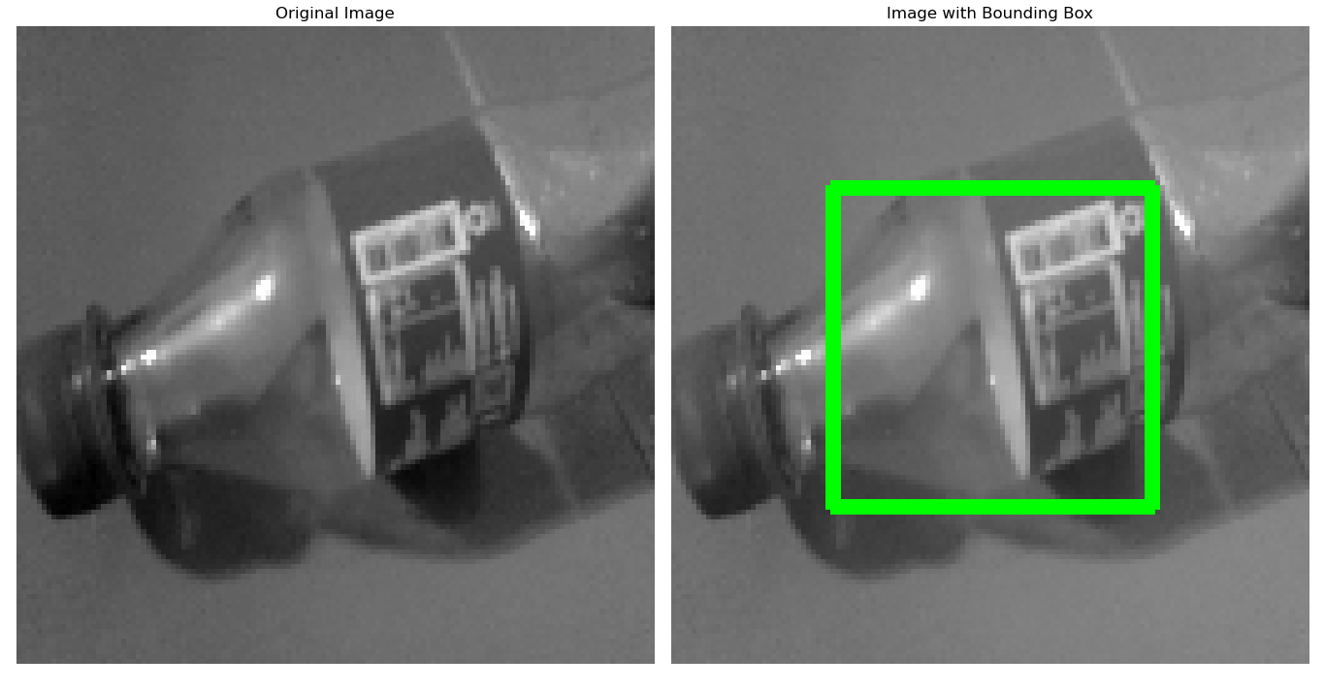

***Figure 10.*** Bounding when the object is detected

As illustrated in the figure, the image undergoes a crucial pre-processing step in the Support Vector Machine (SVM) pipeline known as gray scaling. This technique converts the image to grayscale, reducing it to intensity values and simplifying its features for more efficient analysis. By focusing on essential patterns and textures, gray scaling enhances the model's ability to accurately classify objects.

In the subsequent image, the model demonstrates its object detection capability by drawing a bounding box around the detected object. This bounding box visually highlights the region of interest, indicating the precise location of the identified object in the image. Together, these steps showcase the model's workflow, starting from pre-processing to the final detection and classification of objects.

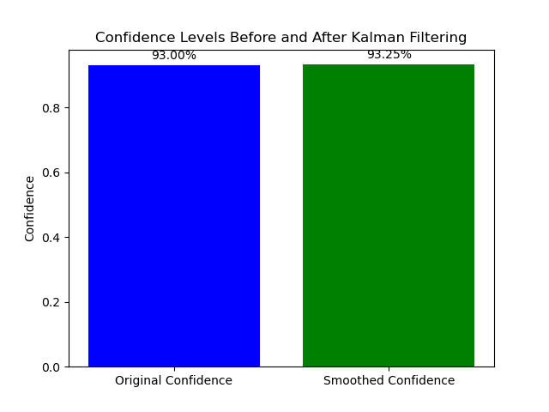

***Figure 11.*** *Before and After Results when applying the Kalman Filter in SVM*

The improvement from 93% to 93.25% in the confidence score after applying the Kalman filter represents a small but notable change. Initially, the SVM model provided a confidence score of 93%, reflecting the probability that an object was identified as a plastic bottle. However, this confidence score could have been subject to minor fluctuations or noise, especially when the classifier faced ambiguous or uncertain features. After the Kalman filter was applied, it smoothed the confidence score by combining the current observation with previous predictions, resulting in a slightly higher, more stable score of 93.25%. This small increase indicates that the Kalman filter was effective in reducing short-term noise and stabilizing the prediction. The filter helped make the confidence more reliable over time by minimizing the effects of any abrupt variations. Although the change was minor, it suggests that the Kalman filter improved the system’s performance by enhancing the consistency and reliability of predictions, which can be especially valuable in real-world applications where even small improvements in accuracy can lead to more robust and 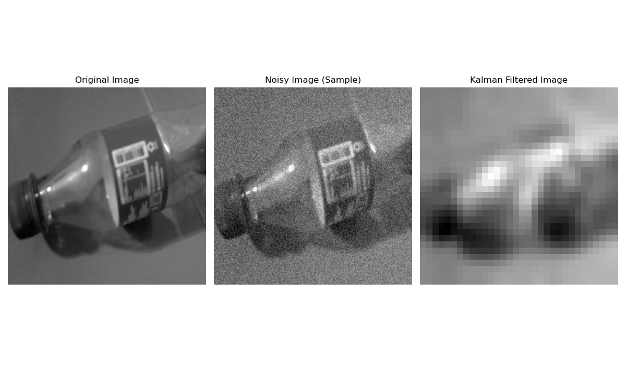trustworthy results

.

***Figure 12.*** *Application of Kalman Filtering*

This image compares three versions of the same scene, featuring a plastic bottle, under different conditions. The Original Image on the left is a clean, high-quality image without any noise, serving as the reference where details such as the label, edges, and shape are clearly visible. The Noisy Image in the center shows the same scene but with significant noise added, resembling visual static that obscures fine details and makes the image harder to interpret. Finally, the Kalman Filtered Image on the right represents an attempt to reduce the noise using a Kalman filter, which smooths the image but at the cost of some blurriness and loss of detail. This sequence demonstrates how noise affects image quality and how filtering can restore clarity, albeit imperfectly

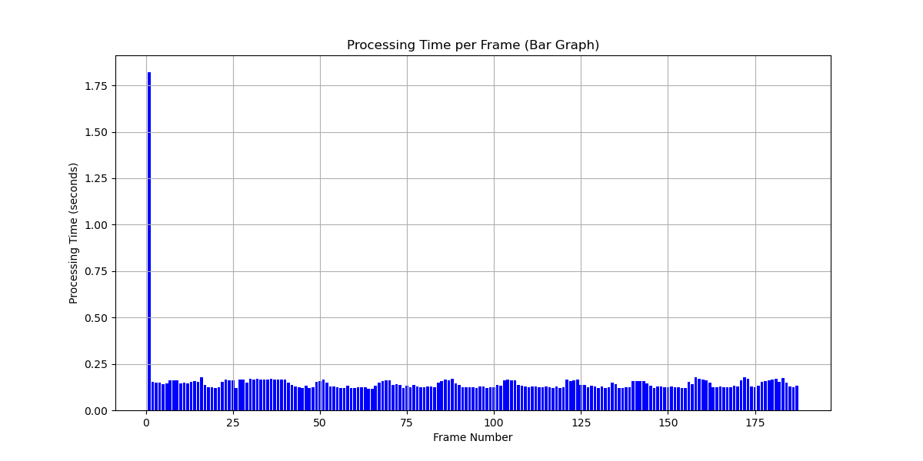

***Figure 13.*** *Processing Efficiency result for fps*

The bar graph shows that the system experiences a significant spike in processing time for the first frame, likely due to initialization tasks such as loading the model and setting up the video capture. After this initial delay, the processing time stabilizes and remains consistently low (around 0.2–0.3 seconds) for subsequent frames, indicating efficient performance during real-time video processing.

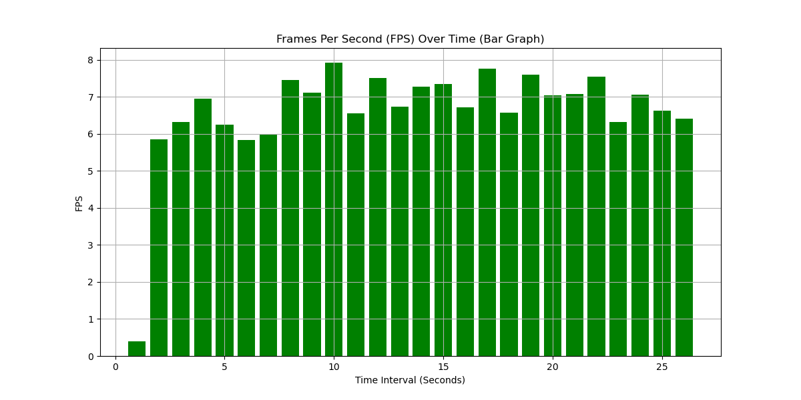

***Figure 14.*** *Frame Rate Reads while System is Running*

The bar graph illustrates the FPS performance of a system over a 25-second interval. The X-axis represents time in seconds, while the Y-axis shows the FPS values, ranging from 0 to 8. Initially, the FPS is low, starting around 1 FPS, likely due to system initialization. By 5 seconds, the FPS stabilizes between 6 and 8, indicating consistent real-time performance. Toward the end, minor fluctuations are observed, but the FPS remains relatively stable. Overall, the system demonstrates reliable frame processing, suitable for tasks like real-time detection and classification.

|  |  |  |
| --- | --- | --- |
| **NORMAL** | **BRIGHT AREA** | **DARK AREA** |
|  |  |  |

***Figure 15.*** *Testing Detection Rate through different conditions*

The figures indicate that the system underwent three tests under different conditions. The first test served as the control, while the other two assessed the system's robustness and adaptability in varying environments. The results show that the control achieved a high detection accuracy of 90% for plastic. In contrast, when subjected to bright light, the accuracy decreased to approximately 82.6%, although it remained detectable. The final test was conducted in a dark environment, which resulted in a further decline in accuracy to 54.9%, reflecting a regression compared to the previous two tests.

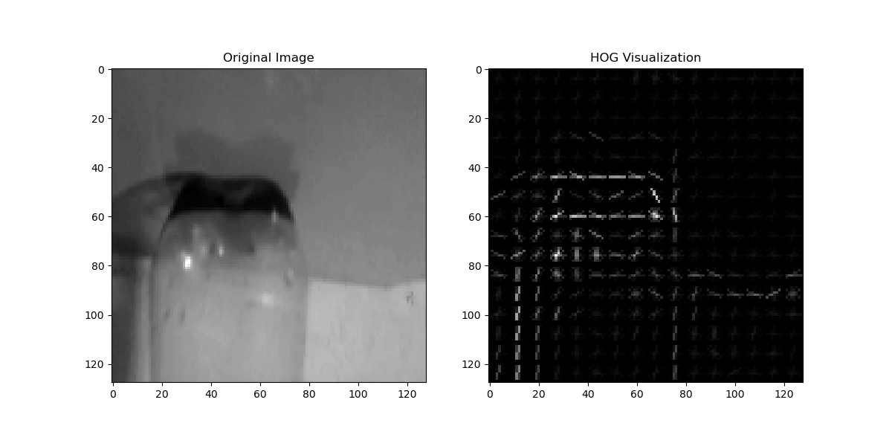

***Figure 16****. using Histogram of Oriented Gradients (HOG) for tracking*

The images demonstrate how the Histogram of Oriented Gradients (HOG) works by dividing the image into small cells, calculating the gradients within each cell, and forming a histogram of gradient orientations. These histograms are then normalized across overlapping cells to create a robust feature descriptor, which enhances the model's ability to accurately classify objects based on their shape and texture.

|  |  |  |
| --- | --- | --- |
| **AVE. Processing Time fps** | **Processing Efficiency** | **Overall Detection Rate** |
| 0.1857 | 5.38 fps | 72.41% |

***Figure 17.*** *Results of the overall tracking Capability*

The table shows the results of the processing efficiency and frame rate in real-time detection where the processing efficiency is at 5.38 fps where it detects the plastic every 5.38 frames while the average processing time per fps is 0.1857, the results shows that the system is relatively efficient when running but not as fast as a typical object detection system, relatively the response of the system may vary with better hardware.

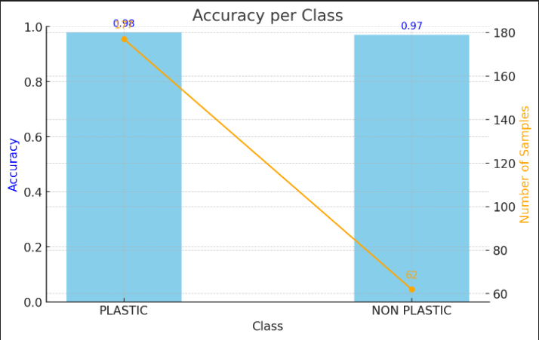

***Figure 18.*** *Accuracy on the trained data graphed in SVM algorithm*

According to the table above, the fine-tuning of distinguishing plastic from non-plastic items did prove to be successful. Eighty-two percent are plastic, while sixty-six percent are non-plastic. Now, that would be a belief in the world of plastic, but to a non-plastic world. The model predicts the wrong item as plastic 0.23 percent of the time.

The calculations are based on sample sizes comprising 177 instances categorizing as "PLASTIC" and only 62 categorized as "NON-PLASTIC." This disparity reveals a significant class imbalance, favoring plastic samples. Consequently, this situation could influence model performance since models typically exhibit enhanced abilities with larger data sets, which might explain why accuracy is slightly elevated for the "PLASTIC" category.

Although these high accuracy rates imply robust classification capabilities for both item types, it remains essential to evaluate additional metrics like precision, recall, and F1-score to gain a comprehensive understanding of how well the model operates. Addressing these metrics within the thesis would provide valuable insights into the strengths and weaknesses of the model, particularly concerning class imbalance and its possible implications on predictive validity.

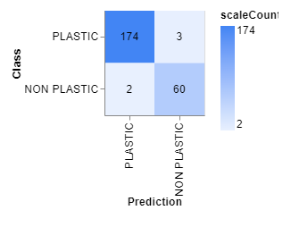

***Figure 19.*** *Confusion Matrix of the sampled data*

This diagram shows a confusion matrix-a highly efficient method for evaluating a classification model by comparing its actual and predicted labels. The rows represent the true classes while the columns denote the predicted classes. Thus, there are two classifications: PLASTIC and NON-PLASTIC.

The value located in the upper-left corner (174) represents the number of accurately identified plastic items, known as true positives. On the other hand, the figure in the upper-right corner (3) denotes how many plastic items were incorrectly labeled as non-plastic; these are called false negatives. Furthermore, the entry at bottom-left (2) indicates how many non-plastic items were wrongly classified as plastic; these instances are classified as false positives. Finally, the number on bottom-right (60) represents non-plastic items that were correctly identified—termed true negatives.

To enhance comprehension further, a color gradient is displayed alongside the matrix. Darker shades correspond to higher counts of item classifications. Ultimately, this confusion matrix offers valuable insights into accuracy rates and reveals instances where misclassifications occurred within the model.

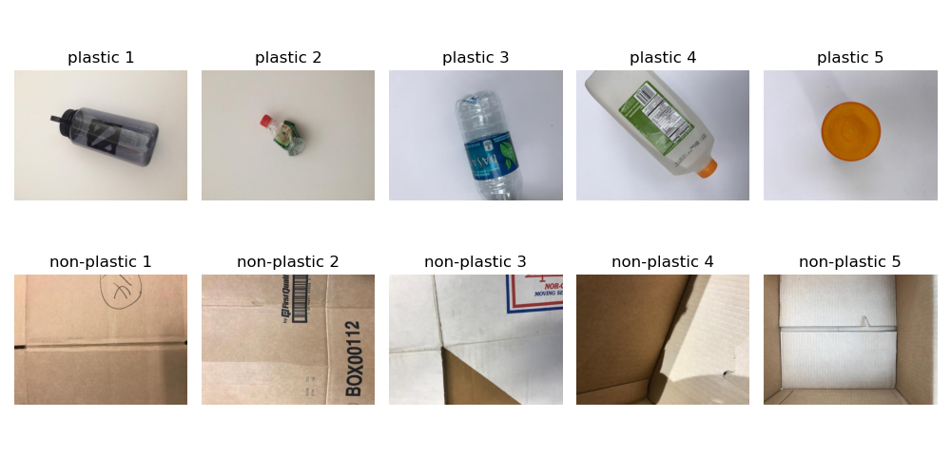

***Figure 20.*** *Simulation of the RVM using SVM Algorithm*

The image shows the examples from the dataset that was used in the project under two headings, namely Plastic and Non-Plastic. The first consists plastic items, such as a water bottle, a crumpled plastic container, a detergent bottle, a plastic bottle cap, and other recyclable plastics. These products represent the positive class, indicating the class that the model should identify correctly as "Plastic." In the same way, the other row has items that are not plastic, such as boxes made of cardboard and paper packaging, forming the negative class for which the model should classify them as "Not Plastic." This diverse dataset demonstrates variations in the size, shape, texture, and orientation of objects, replicating real-world conditions. This type of variation is essential to train the deep learning and SVM-based model for distinguishing between recyclable plastic and other waste. Such examples show the complexities of classification, thereby emphasizing the importance of rigorous training to ensure proper performance in real-world reverse vending machines.

# SUMMARY, CONCLUSIONS, AND RECOMMENDATIONS

## 5.1 Summary

## This thesis delves into the design, development, and production of a Reverse Vending Machine having a highly advanced detection of plastic bottles using deep learning and SVM techniques; this automatic system, firstly, recognizes an identifying process that is actually applied to automated recycling. It is built to target the major problem of plastic waste in the environment.

## That is, this system uses deep learning, such as convoluted neural nets, for the identification of plastic bottles from images and SVM for classification based on features extracted from deep learning. The integration of these two ensures the precise detection and sorting of recyclable material in a much more effective recycling process.

## The project has demonstrated how this system will estimate the automatic identification of plastic bottles, cutting down on contamination, and hence enhancing the quality of the recycling products. This project, therefore, demonstrates the potential for AI-enabled solutions to automate waste management processes and thus move towards one of the pillars of a more sustainable circular economy. In the future, one might consider increasing adaptivity and accuracy through expanding recognition of a wider spectrum of materials and optimizing real-world implementations.

## In conclusion, the RVMs developed with SVM and deep learning represent a potent combination for reducing plastic wastes, improving recycling rates, and promoting sustainability.

## 5.2 Conclusions

Recycling is being taken to the next level through the installation of a Reverse Vending Machine (RVM), offering deep-learning ability for better plastic bottle detection along with Support Vector Machine (SVM) technology. This technology employs deep learning algorithms for object recognition and SVM to classify items, thus detecting and sorting plastic bottles with more precision, and hence makes the recycling process more efficient and automated. Furthermore, Support Vector Machine and Convolutional Neural Network Algorithms are incompatible to each other, do approach by classification and detection differently. Key findings and contributions of the project include:

The proposed project describes a possible application of deep learning and support vector machine in the development of smart reverse vending machines; by providing quality assurance of these machines through improved detection and classification capabilities, such systems can make an enormous contribution in raising recycling rates, reducing plastic pollution, and ensuring a sustainable future.

The effective application of support vector machine using classification based on the deep learned features as a legitimate classification was very well addressed. The SVM really facilitated an enhanced framework for decision-making that could handle the non-linear nature and interrelationship of features of plastic bottles leading to better predictions.

In an impact of sustainability inside this work of an RVM-equipped unconventional detection system, through further reduction of plastic waste generated within the environment, it may serve the purpose of incentive required by the public to return plastic bottles placed in those centers and thus promote the circular economy.

Integration of AI and Automation: The integration of AI techniques, including convolutional neural networks for image analysis, and SVM for classification demonstrated a good opportunity for automation in waste management systems. This, in turn, will enhance the accuracy and efficiency and reduce manual sorting, lowering operational costs and improving processing times.

Future Directions: Future works would aim at improving the efficiency of the system in identifying a wider range of plastic bottles and materials. The system could thus be extended for real-time data collection, thereby increasing its adaptability to various environmental conditions and capacity for large-scale deployment.

## 5.3 Recommendations

For Future studies related to the paper, the researchers observed or deduced that the prototype is only limited to 2 classes only which is Plastic and Non-Plastic thus making room for more improvements namely;

* Development of Mobile Application
* Improving the Prototype Design
* High Quality shots of sampling images

REFERENCES

[1][4] Yusof, Norfadzlia Mohd, et al. “Smart Waste Bin with Real-Time Monitoring System.” *International Journal of Engineering & Technology*, vol. 7, no. 2.29, May 2018, p. 725. <https://doi.org/10.14419/ijet.v7i2.29.14006>.

[2][3] Ramson, S. R. Jino, et al. “An IoT-based bin level monitoring system for solid waste management.” *Journal of Material Cycles and Waste Management*, vol. 23, no. 2, Nov. 2020, pp. 516–25. <https://doi.org/10.1007/s10163-020-01137-9>.

[5] Monteiro, Matheus Santos, et al. *Solid waste management and monitoring system for smart cities: development of a low-cost sustainable IoT architecture using GPRS/GSM*. Nov. 2021, <https://doi.org/10.1109/wcnps53648.2021.9626317>.

[6] Mamun, Md. Abdulla Al, et al. “Theoretical model and implementation of a real time intelligent bin status monitoring system using rule based decision algorithms.” *Expert Systems With Applications*, vol. 48, Apr. 2016, pp. 76–88. <https://doi.org/10.1016/j.eswa.2015.11.025>.

[7] Shi, Y.; Lv, L.; Hu, F.; Han, Q. A Heuristic Solution Method for Multi-Depot Vehicle Routing-Based Waste Collection Problems. Appl. Sci. 2020, 10, 2403.

[8] Hussain, A.; Draz, U.; Ali, T.; Tariq, S.; Irfan, M.; Glowacz, A.; Antonino Daviu, J.A.; Yasin, S.; Rahman, S. Waste Management and Prediction of Air Pollutants Using IoT and Machine Learning Approach. Energies 2020, 13, 3930.

[9] Laurieri, N.; Lucchese, A.; Marino, A.; Digiesi, S. A Door-to-Door Waste Collection System Case Study: A Survey on its Sustainability and Effectiveness. Sustainability 2020, 12, 5520.

[10] Moreschi, L.; Del Borghi, A.; Taramasso, A.C.; Gallo, M. Waste Management under Emergency Conditions: Life-Cycle Multicriteria Analysis as Decision Support System. Resources 2020, 9, 82.

[11] Abba, S.; Wadumi, N.J.; Lee, J.A.; Liz Crespo, M. Design and Performance Evaluation of a Low-Cost Autonomous Sensor Interface for a Smart IoT-Based Irrigation Monitoring and Control System. Sensors 2019, 19, 3643.

APPENDICES

##### <Appendix A:> <Title>

Place your appendices here. Please be sure that these have been referenced in the body of document.

Example:

Appendix A: Relevant Source Code (put headings with complete explanation)

Appendix B: Sample Input/Output

Appendix C: User’s Manual/User’s Guide if applicable

Appendix D: Certifications (Certificates from English Critic, Statistician, Grammarly, Adviser, Acceptance from the Agency)

BIO NOTE